Adhesive Sports and Fashion - Associate of Key Account Management Busan

Location: 부산오피스 – 부산광역시 사상구 낙동대로 943번길 235 (감전동) 1동

Application: <https://henkel.csod.com/ux/ats/careersite/1/home/requisition/72125?c=henkel&sq=25080106>

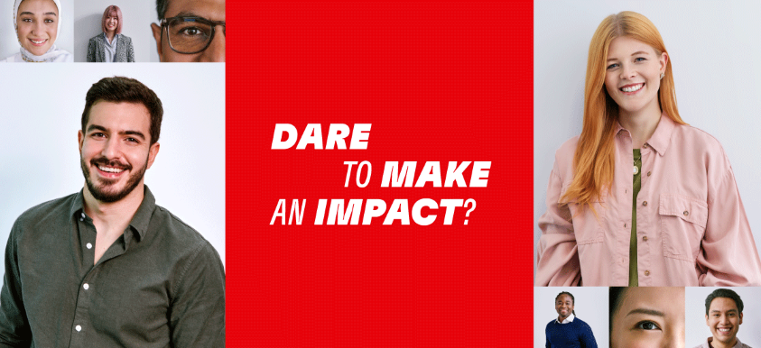

**About this Position**

This position drives strategic sales initiatives and key account management for Tier 1 footwear manufacturers by developing tailored strategies and leading innovative projects. Also, this position builds strong relationships with customers and cross-functional global teams to ensure value delivery and alignment with customer expectations and leads complex negotiations and identify new business opportunities while managing pricing, claims, and contract processes effectively.

**What you´ll do**

* Develop and execute sales strategies using a key account approach focused on Tier 1 footwear manufacturers
* Coordinate and drive innovative projects and their proliferation
* Demonstrate professional global project management that ensures customer visibility and delivers value
* Build strong, long-term relationships with customers and internal stakeholders across all communication levels
* Interact regularly with global Henkel teams, including Sales, Application Engineering, Marketing, and Innovation
* Lead complex negotiations with a strategic and multifaceted approach
* Identify and develop opportunities to expand market share and explore new business, presenting findings to leadership
* Determine strategic account direction aligned with customer expectations, including innovation and product development
* Ensure prompt and strategic responses to customer inquiries and market/product developments using an agile approach
* Control and support pricing, claims, payments, and contract negotiations

**What makes you a good fit**

* Bachelor’s degree in Business Administration, Marketing, Engineering, or a related field is required
* Chemical Science, Polymeric Engineering Science and other chemical related degree is preferred
* Entry level can apply
* Strong interest in Footwear (Sports and Fashion) industry is required
* Business level of Korean and English communication skills are required
* Able to work in Busan Korea (no VISA application supported by the company) and travel for business abroad and nationwide

**Some perks of joining Henkel**

* Diverse national and international growth opportunities
* Gender-neutral parental leave for a minimum of 8 weeks
* Globally wellbeing standards with health and preventive care programs
* Employee Share Plan with voluntary investment and Henkel matching shares
* Support for Employee Contributions of National Health Insurance
* Retirement Pension DC
* Support for Medical Check-up

At Henkel, we come from a broad range of backgrounds, perspectives, and life experiences. We believe the uniqueness of all our employees is the power in us. Become part of the team and bring your uniqueness to us! We welcome all applications across different genders, origins, cultures, religions, sexual orientations, disabilities, and generations.